(Approx. 891 words)

Make Windows 10 Faster
By David Kretchmar, Computer Technician, Sun City Summerlin Computer Club
April 2020 Gigabyte Gazette
www.scscc.club
dkretch (at) gmail.com

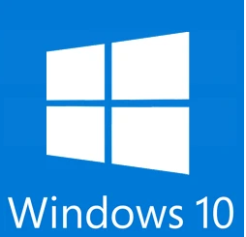
Support for Windows 7 is now history. Support for Windows 8 will last for 3 more years. Windows 8 mostly consisted of intermediate steps (and missteps) toward Windows 10. In 2020 I can think of no reason for any user to be running Windows 8 instead of Windows 10, especially since Windows 10 is superior and is a free update to Windows 8. So, if you are one of the few users still running Windows 8 there is no better time than now to upgrade to Windows 10.
Most of us have used Windows 10 for a few years now; Windows lacks the flexibility of the flavors of Linux, and the slick user interface of Mac’s Catalina, but is the operating system installed on the majority of home computers now.
Windows 10 is Microsoft’s best operating system so far but is not perfect. However, it is virtually infinitely customizable and I’m going to make a few suggestions that will help you get the most out of your windows 10 system.

Keep Windows Up to Date
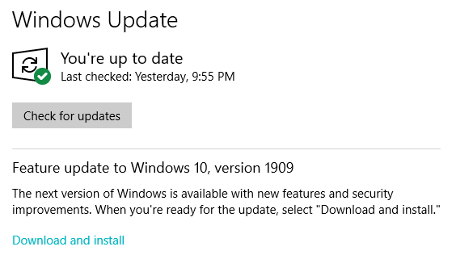
Windows is issuing updates on a weekly basis and these are important not only for the operating system and peripheral issues corrected but also for keeping your security malware definitions current. Go to Update Settings and confirm that updates are current. Hit Check for Updates to verify this. This is also where you can learn if your system is running the latest update to Windows 10 (1909) and possibly complete this process (as is required in the dialogue box shown). Under Advanced Settings you can make sure auto-updates is checked.

Disable Cortana
She needs to just shut up. For most users, Cortana is just an annoyance built into Windows 10. She mostly gives users annoying pop-ups, she is constantly gathering data, and does little more than try to force us into Bing searches. In this day of actually useful voice assistants, such as Google or Alexa, Cortana seems oddly dumb. I have learned to disable Cortana during the installation of Windows but if you have not had this opportunity shutting her off is easy. Go to Cortana under Settings and toggle all sliders off.
Go back to the main Settings window and under Privacy Settings you can turn off the sliders for speech and inking and typing to reduce the amount of data Cortana gathers on your computer usage. You can also block Cortana from accessing your microphone and camera on the privacy page. This is also a good time to review all your privacy settings to make sure you are putting as little information as possible out there.

Disable Notifications
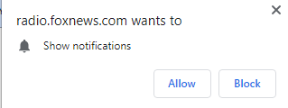
Many users are unaware of why they are constantly getting popups from the Notifications icon on the lower right-hand corner of your Taskbar. These popups use system resources and can be a pain when they interfere with your computer use. Go to Settings, System, Notifications, and actions and toggle off Notifications. Like magic, they will no longer appear! You will still have many web pages offering notifications, but you can just say “NO!” by hitting “Block” or “Don’t Allow”.

Disable Startup Apps
Go to your Task Manager Startup tab and disable any programs you do not need running immediately every time you go into your operating system. Microsoft OneDrive and speech recognition ore a couple of major resource hogs. Toggle off anything you do not need running all the time. Remember, you are not removing any programs and you are not preventing them from firing up when you need them.

Log-in Faster
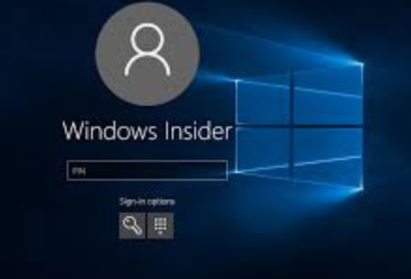
The Windows 10 log-in screen is an excellent example of a worthless “improvement”. Having to swipe up or down or hit “Space” is a step Microsoft somehow felt was necessary; typing in your password takes even more time. Most users prefer to use a four-digit PIN; just enter 4 digits and there is no need to even hit Enter. To set a PIN go to Settings, then Sign-in options. Click on Windows Hello PIN and set your 4-digit PIN. Note that a little further down on this page you can disable the requirement for a sign-in after you’ve been away from your computer for a while.
If you want to remove the sign-in password requirement, type “NETPLWIZ” in the search box then use this application to disable the password requirement for your computer.

Disable Background Apps
This is not necessary on a new powerful system, but if yours is older you might want to look at these under Privacy/Settings. With an older system performance might be improved by unchecking anything you don’t need running.

Uninstall Unneeded Programs
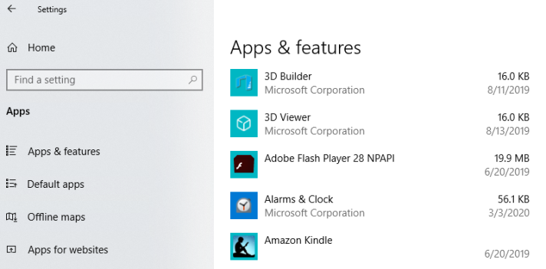
Talking about unnecessary stuff included with Windows 10, there is a ton of “Bloatware” included on most new store-bought systems you can just ditch. Right-click on Start and click on Apps and Features. Scroll through the list and you will see a lot of programs on your system that you never use. Games such as Candy Crush and security programs such as Norton or MacAfee are major offenders in this area. Here is where you can simply uninstall the unused applications, freeing up room on your hard drive, and ensuring these programs will not try to load and take system resources in the future.

